Microimplant Anchorage in Orthodontics

*Hee-Moon Kyung, **Bong-Gyu chang,*** Seong-Min Bae
*Professor, ** Post-graduate student, *** Clinical Associate Professor
Department of Orthodontics
Dental School, Kyungpook National University, Daegu, KOREA
188-1, Sam Duk 2 Ga, Jung Gu, Daegu, KOREA 700-412
Fax: +82-53-421-7607
Email: hmkyung@knu.ac.kr

l. Introduction
The control of anchorage is one of the most critical factors in orthodontic treatment. The reinforcement of an anchorage usually needs a complicate biomechanics and a patient compliance. Also, there are many times when absolute anchorage is needed. But, considering Newton’s Third Law, it is virtually impossible to achieve absolute anchorage condition in which reaction force producing no movement at all, especially with intraoral anchorage. Thus extraoral anchorage, such as head gear, is traditionally used to reinforce anchorage. However, the use of extraoral anchorage demands full cooperation of patient as well as 24 hours of continues wear which cannot be done. Therefore, it is extremely difficult to attain excellent result without compromising treatment in some way.
Therefore, to treat patients without patients’ compliance, clinicians and researchers have tried to use skeletal anchorage. Gainsforth and Higley(1945) placed metallic vitallium screws in dog ramus as anchors and applied elastics to the maxillary arch wire for distalization of maxillary dentition as long ago as 1945. However, all screws were failed within one month. There were no more published reports of attempts to use skeletal anchorage to move teeth until the clinical case report of Linkow(1969,1970) who used mandibular blade-vent implants in a patient to apply class II elastics.
After Brånemark and co-workers reported successful osseointegration of prosthodontic implants in bone, osseointegrated implants (Sherman, 1978; Roberts et al., 1994; Wehrbein et al, 1999) have been used as intraoral orthodontic anchorage, but their usage has many limitations for routine orthodontic practice. First of all, it is hard to select a proper insertion site for a conventional implant in orthodontic patients due to the large diameter of implant. Also, waiting time for osseointegration, high cost, severity of surgery, etc. are troublesome for patients and orthodontists. Thus a smaller diameter miniscrew is tried to use for orthodontic anchorage rather than bulky previous conventional dental implants. Creekmore & Eklund(1983) reported the use of a small-sized vitallium bone screw as anchorage for the intrusion of maxillary incisors. The screw was inserted below the anterior nasal spine, and elastic thread was applied to the archwire. After treatment, maxillary central incisors were elevated about 6mm. The screw was stable over a long period of time without infection, pain & pathologic. Even though the successful use of the screw for orthodontic treatment, there was no clinical report using screws for orthodontic treatment until Kanomi(1997) introduced micro-screws as orthodontic anchorage. He showed that 1.2mm diameter of micro-screw is enough for intrusion of anterior teeth.
Since 1998, Park & Bae (Park, 1999; Park et al, 2001; Bae et al, 2002; Bae et al, 2002) have started to use surgical micro-screws (1.2mm in diameter) to retract anterior teeth after placing them between the roots of upper 2nd premolars and 1st molars. It was very successful without any complications. Also they showed that almost all kinds of tooth movement were possible including molar intrusion, molar protraction and whole dentition retraction etc. using small diameter of micro-screw. They showed that micro-screw head can be exposed when it is placed on the attached gingival area. Originally, micro-screw is used to fix mini plate into bone in surgical fields. So, it was difficult to apply orthodontic elastomers onto the screw head without forming connectional ligature wire loop on the cervical portion of the screw. Thus, there was periodontal involvement caused by the location of ligature wire, which is under screw and towards gingival, even though screw was located on the attached gingival area. This location allowed gingival embedment of ligature wire producing steady irritation on soft tissue and also caused difficulty to patient in keeping good oral hygiene around the screw.
To compensate these drawbacks, Kyung et al (2003) developed orthodontic Microimplant (Absoanchor), which has been designed specifically for orthodontic purpose and has a button-like head with a small hole. Also, by giving inclination on cervical area of the button allows natural separation of elastomers from gingiva. A hole is made in upper structure for smooth application of elastomer such as elastomeric thread and/or ligature wire. This newly designed microimplant has helped to solve the main objections to previous implants and surgical screws (Sung et al,2006). We designed several sizes of diameter from 1.2 mm to 2.7 mm of micro-implants with different types of head for different tasks and sites ( Fig.1).
However, many orthodontists are still hesitating to use orthodontic microimplants, because many of them are afraid of surgical intervention and post-surgical complications. But unlike prosthetic implants, there is little complication, and every dentist including orthodontist can insert orthodontic microimplants. Here, we would like to describe how to use microimplant system (Absoanchor, Dentos Inc., Daegu, Korea) as an orthodontic anchorage in daily practice.

2. Terms used in skeletal anchorage
There are many terms used in orthodontic skeletal anchorage, such as, skeletal anchorage system, mini-screw, micro-screw, mini-implant, micro-implant, mini-screw implant, micro-screw implant, Temporary Anchorge Device(TAD) etc. A prefix of micro- comes from Greek and mini- comes from English. The term micro- and mini- are same meaning of small when they are used as adjective. Generally, however, micro– is used to express a little smaller size than mini-, such as mini-car and micro-car, mini-scan disk and micro-scan disk. Academically the term of micro- is used more rather than mini-, for example, micrognathia, microglossia, microdontia, etc. Also, implantologists already used the term mini-implant, which is a kind of temporary implant to make temporary crown during osseointegration of implant. The diameter of prosthodontic mini-implants is a little bit larger than orthodontic ones. The term skeletal anchorage can include all kinds of skeletal anchorage devices including prosthodontic implant, onplant, etc. Many doctors are using the term TAD. However, almost all kinds of conventional anchorage, such as transpalatal bar, lingual arch, etc. can be classified into temporary anchorage device. Prosthodontic implants vary to screw implant & non-screw implant. Usually, however, we do not call them screw-implant or non- screw implant. Every orthodontic implant has screw portion. For the same reason, we don’t need to put the term screw, such as micro-screw implant. Therefore, we prefer to use the term microimplant for orthodontic screws.

3. Types of Absoanchor Microimplants

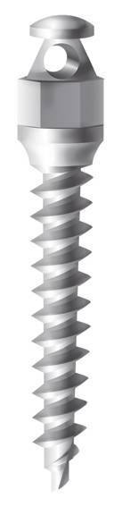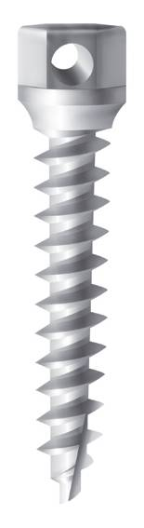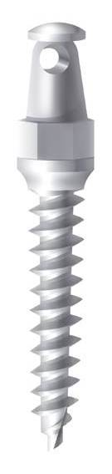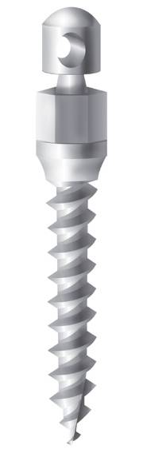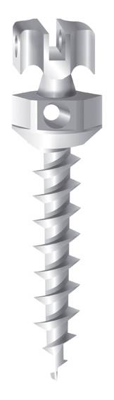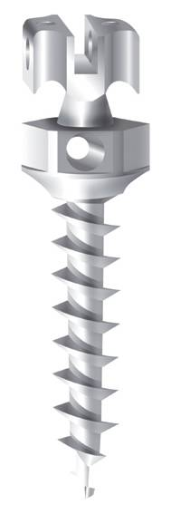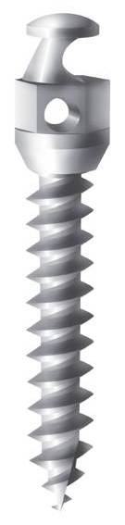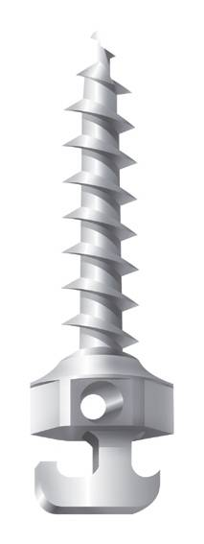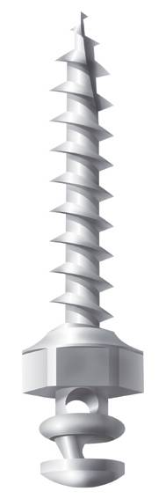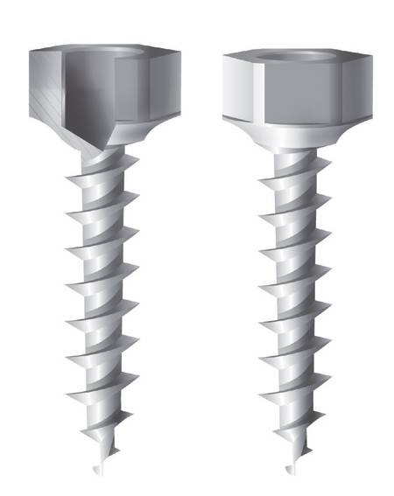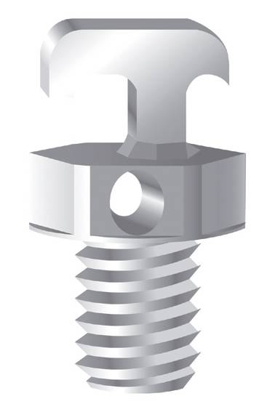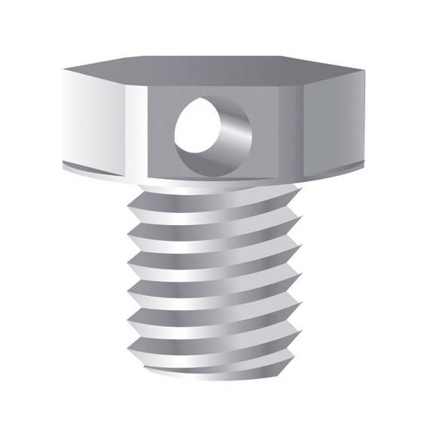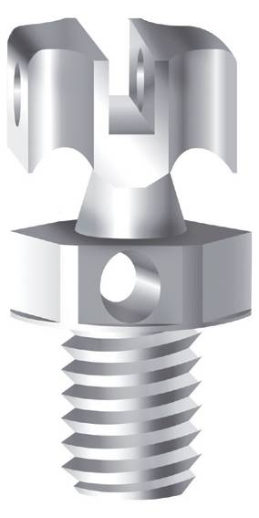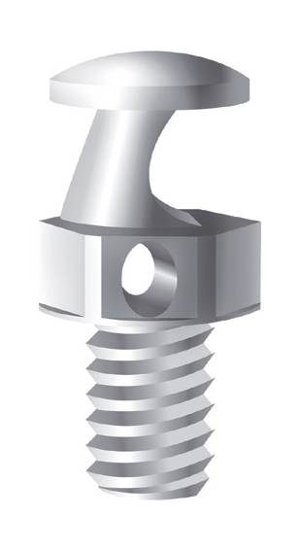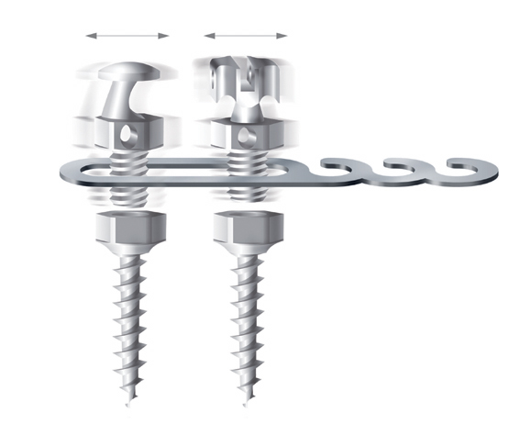
Fig.1. Various types of Absoanchor microimplants.

Several types of Absoanchor microimplants are available for different tasks and sites (Fig.1). Different types of head structures can be chosen depending on kinds of elastomers, biomechanics, sites of placement and individual preference etc. In Bracket head type, two kinds of screws are designed depending on the driving directions. Left Handed Screw should turn counter clockwise direction during driving. Depending on the direction of moment, we can choose Right or Left handed screws ( Fig.2 and 3).
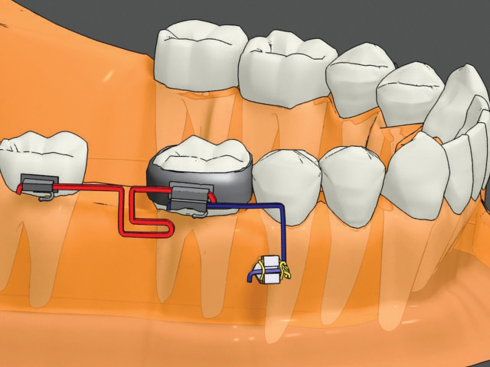
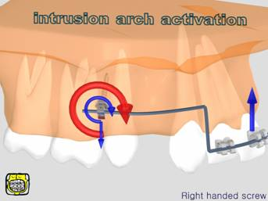
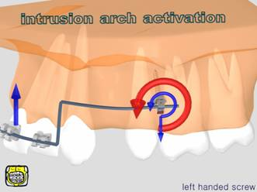

Fig.2. Possible applications of right-handed and left-handed Bracket Head (BH) type screws.
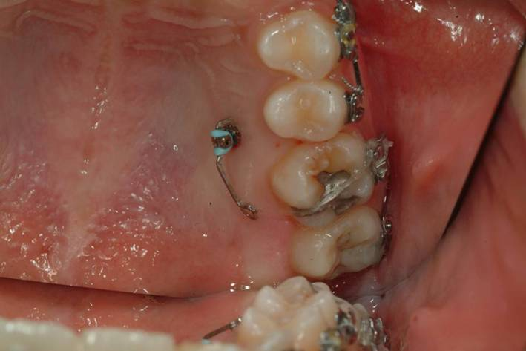
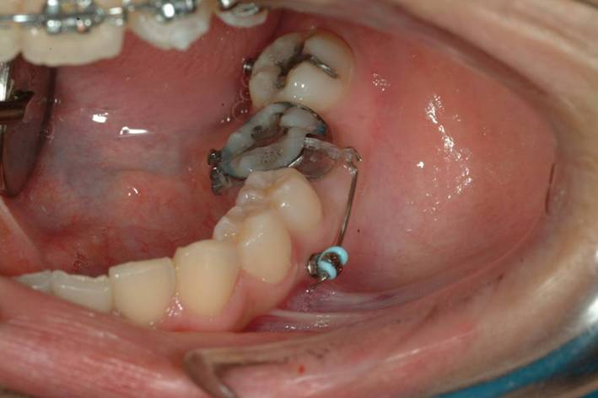

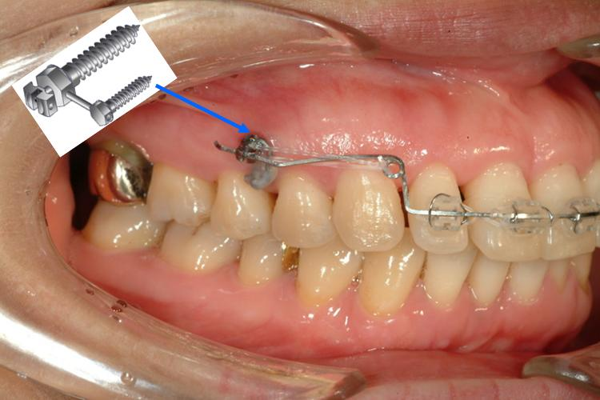
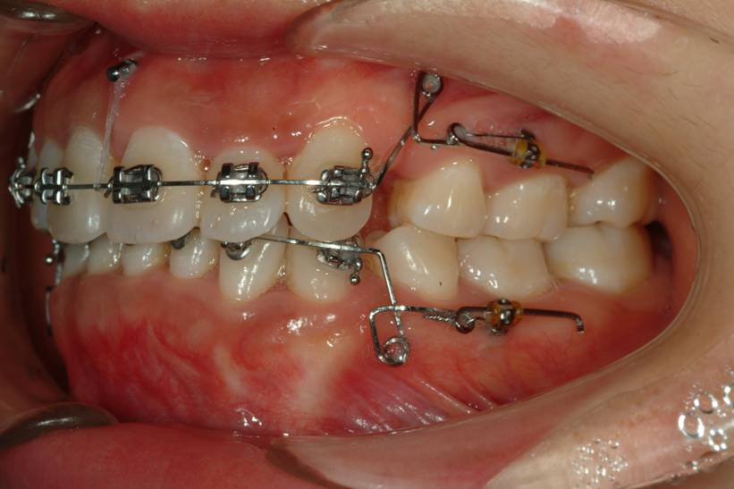

Fig.3. Clinical applications of Bracket Head type microimplants.

4. Selection of microimplants
1) Depending on the length;
The length of screw portion is ranging from 5mm to 12 mm. Longer microimplants lead to better mechanical stability like dental prosthetic implants, but more possibilities of invading adjacent anatomical structures, such as roots, maxillary sinus and nerve etc. According to our clinical experiences, 6mm of screw depth is enough for maxillary bone, and 5mm is enough for the mandible. However, always we should consider the depth of soft tissue when choosing proper length of microimplantsd. Especially palatal mucosa may be very thick in many. So, if soft tissue is 6mm thick, in order to place 6mm of screw portion into the bone, at least 12mm length of microimplant should be chosen. This protocol requires that the soft tissue thickness as well as the bone quality must be evaluated at the location of placement.
Also, in choosing the proper length of a microimplant, the path of insertion of the microimplant must be considered. A microimplant can be placed either in a diagonal direction or a perpendicular direction relative to the cortical bone surface. It is better and easier to place microimplant in a perpendicular direction, but, there are many situations in which the microimplant should be placed in a diagonal direction so as to avoid injury to an adjacent tooth root. When the microimplant is placed in a diagonal direction rather than perpendicular direction, it is better to use a slightly longer microimplant (Fig.4).

2) Depending on the diameter;
There are various diameters of Absoanchor microimplants which are ranging from 1.2 mm to 2.7 mm, so they can be placed anywhere in the mouth. Depending on the inter-radicular distance, quality of bone and site of placement, we can choose different diameters of microimplants.
Thicker the microimplant, the greater becomes mechanical retention, but also the greater possibility for root contact. By authors’ experiences, the thicker microimplants do not always guarantee higher success rate, even there is a report that microimplant of smaller diameter showed higher success rate than thicker ones (Kuroda et al,2007-a). Also thicker microimplants may be hard to remove due to osseointegration, author prefer microimplants of smaller diameter as possible. When we place the microimplants between root, if we choose bigger ones, we can have more chance to touch the roots. If microimplant is touched to the root, the failure rate will be increased significantly (Kuroda et al, 2007-b)
Followings are general tips for selecting proper diameter of microimplants depending on the inserting sites;

a. buccal & labial areas of maxilla : Cortical bone in these areas is not that thick, so use tapered microimplant neck of 1.3-1.4mm and tip of 1.2-1.3mm thick. Microimplants made by titanium alloys of this thickness can be inserted safely without pre-drilling on maxillary buccal areas.
b. palatal areas of maxilla : Soft tissue is thick, so usually microimplants of longer than 10mm is needed, but the longer, the higher possibility of breakage, so use a little thicker ones ( 1.5-1.6 mm of neck ) than buccal areas. The distance between roots is greater in palatal areas than buccal area, there is lower possibility of root contact even when using thicker microimplants.
c. midpalatal suture : There is no worries for root contact, and also this is sutured area, so thicker ones are used. Microimplants of diameter larger than 1.7mm is recommended. Even 2.7mm thick one can be used for younger cases.
d. buccal & labial areas of mandible : Cortical bone of mandible is harder than maxilla, so, a little thicker ones (1.4-1.6mm) are better to prevent breakage especially for self-drilling (drill-free) method.

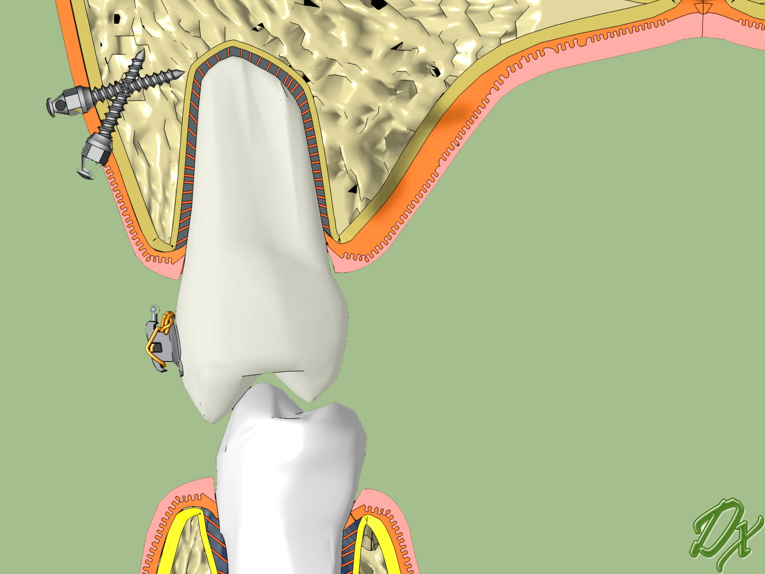

Fig.4. Diagonal (oblique) & perpendicular insertion of microimplants.

5. Surgical procedures of microimplant installation

1) Local Anesthesia
Local anesthesia is only needed to the site to be inserted, and less than 1/4 dental lidocaine ample per site is enough. Sometimes, only topical anesthesia (Fig.5) is enough to insert on the attached gingival area. The effect of anesthesia does not need to be deep, only soft tissue and periosteum should be anesthesized. Periodontal ligament should not be under anesthesia, for PDL is the most useful clinical indication of root contact because patients can feel pain when drills or microimplants are touching roots.
For thickness of palatal mucosa varies to persons, thickness should be measured by probe or dental needle (when injecting lidocaine) (Fig.6), so that it could be a guide when selecting proper length of microimplant. If there is an extraction case, microimplant should be inserted right before extraction (of course after anesthesia) in order to avoid additional anesthesia.

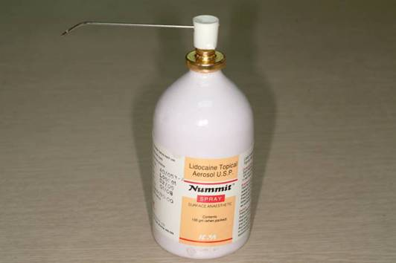
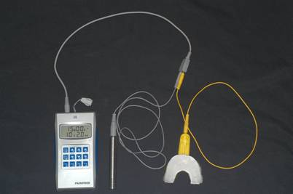
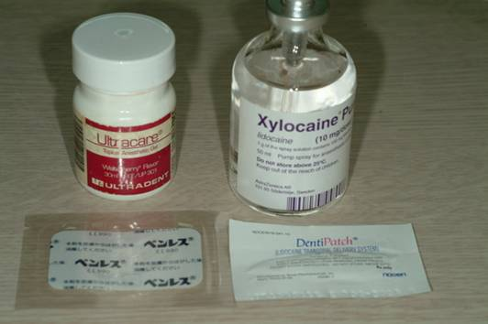

Fig.5. Various kinds of topical anesthetics.

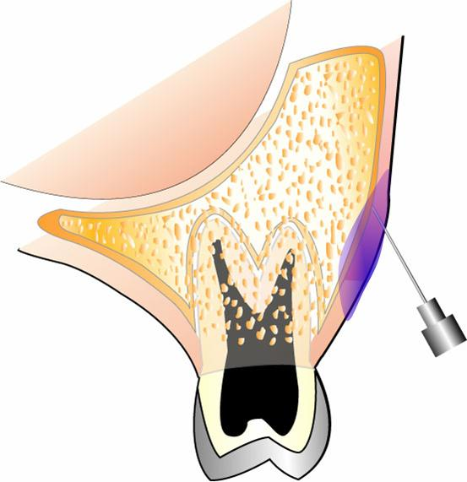
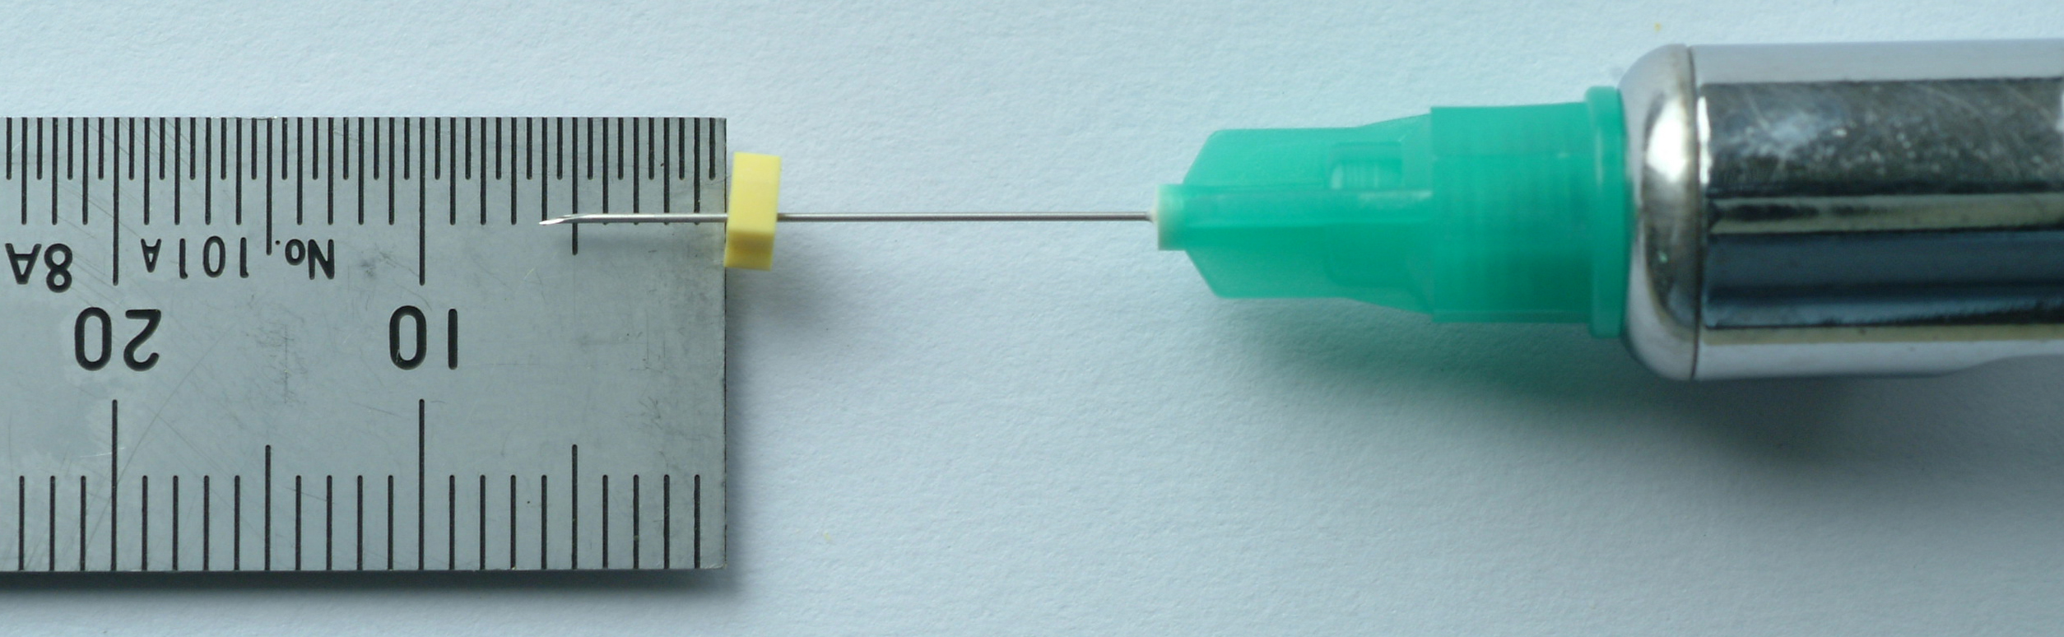

Fig.6. Anesthesia should not too deep, only to soft tissue and periosteum. When injecting lidocaine, thickness of palatal soft tissue should be measured.

2) Pilot Drilling
When using drill-free method (Fig.7), microimplant of small diameter is likely to be broken when alveolar bone is too hard. Therefore microimplant is safely installed by pre-drilling method (Fig.8) especially on adults’ mandibular areas. You may drill only through cortical bone to prevent fracture. However, it’s better drill up to the length of microimplant to install. It is because we can know whether to contact root of the teeth in advance, since drill may touch the root in the direction. We may not concern of perforation of root during drilling. The diameter of pilot drill should be at least 0.2~0.3㎜ smaller than that of microimplant for proper initial mechanical stability.

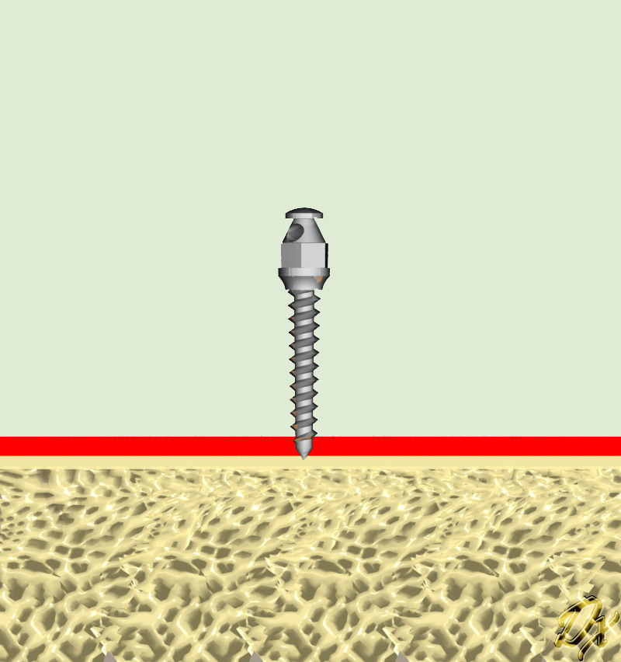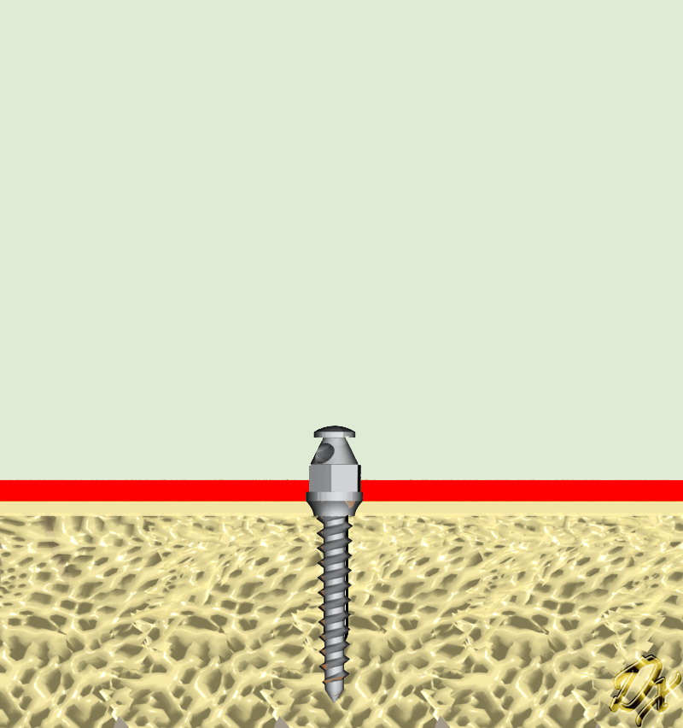

Fig.7. Drill-free (self-drilling) method.

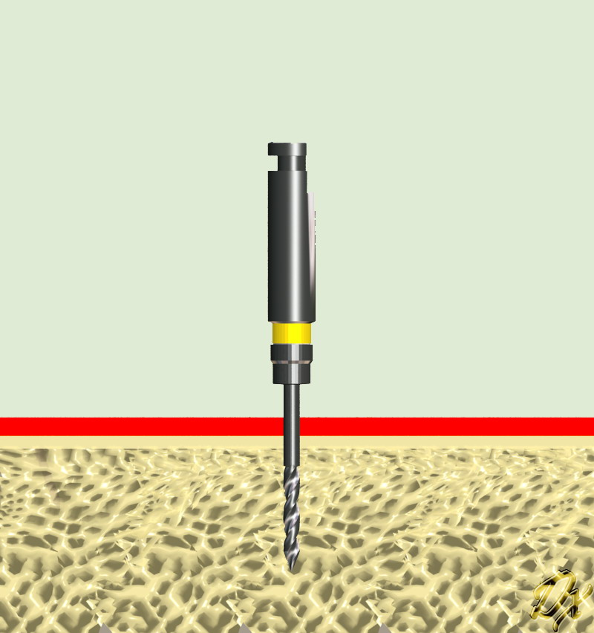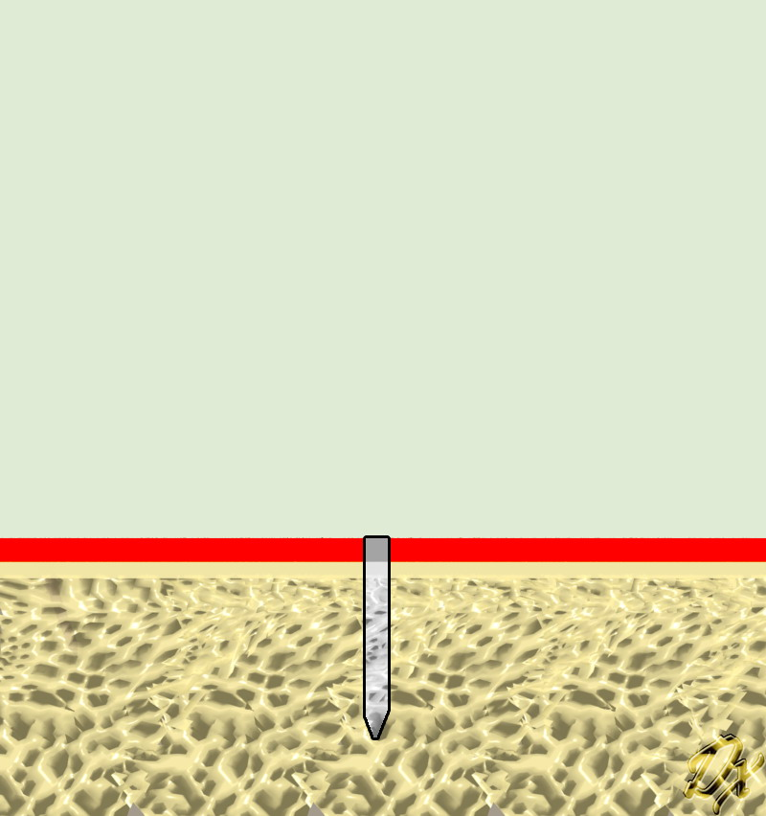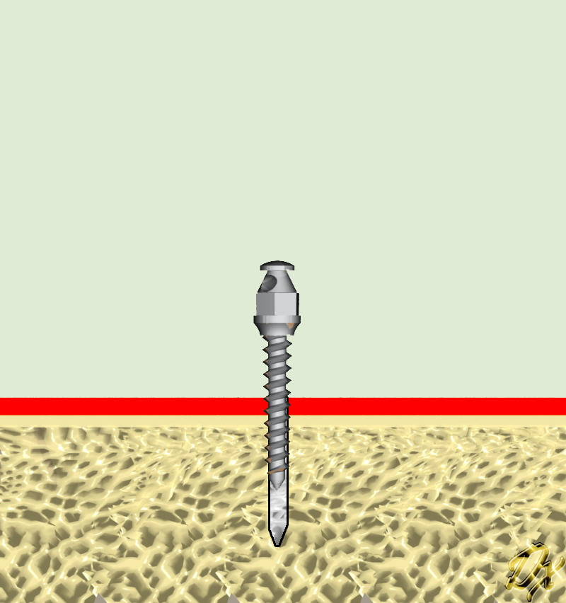

Fig.8. Pre-drilling (self–tapping) method.

Before we start drilling, beginners would be better to mark where to drill by brasswire (Fig.9) or probe on the attached gingiva. You must check whether drill is not curved before you start drilling.
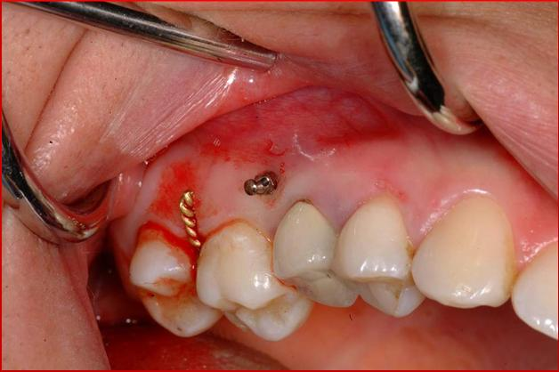
Fig.9. It could be useful to mark drilling site with brasswire etc.

When drilling site is on attached gingiva, incision of soft tissue is not needed. To reduce heat production, drilling speed should be around 500-1000rpm, and rotate intermittently with normal saline irrigation. To increase torque with reduced rpm, prosthetic implant engine is a good but expensive choice, so speed reduction contra angle (64:1 or 20:1, Fig.10) would be a reasonable choice. Non-speed reduced low speed (1:1) contrangle gives high rotation speed (maximum 30,000 rpm) which leads to excessive heat production. On the other hand, lowering rotation speed of 1:1 contraangle to reduce heat leads to weaker torque, so that it may not penetrate hard bone.
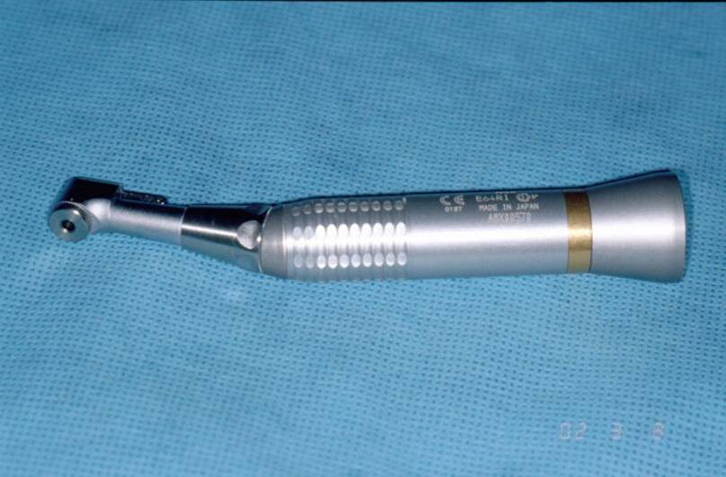
Fig.10. Speed reduction contraangle (64;1) for drilling purpose.

In general, drill with angulation of 30-60 degrees with root axis, not perpendicular, when installing between the teeth in buccal and palatal areas (Fig.4). The volume of alveolar bone varies depending with persons, and with greater bone volume, we can reduce angulation between the teeth, so that reduce root contact. To prevent slipping of drill, we should drill perpendicular to the bone surface at first, and then change the direction to drill our own angulation. We should always keep in mind that the thickness of cortical bone may vary between the patients, also each side, and even by sites in same person.
When drilling on the movable soft tissue, not attached gingiva, we should make vertical incision of about 4mm before drilling (Fig.11). This is to prevent soft tissue to be rolled up around drill. If we are not feel free to make incision, you can use drill guide to prevent rolling of soft tissue (Fig.12). If we feel another resisting force after penetrating cortical bone, drill may be contacting the root. Also patients may feel pain if anesthesia is not too deep.

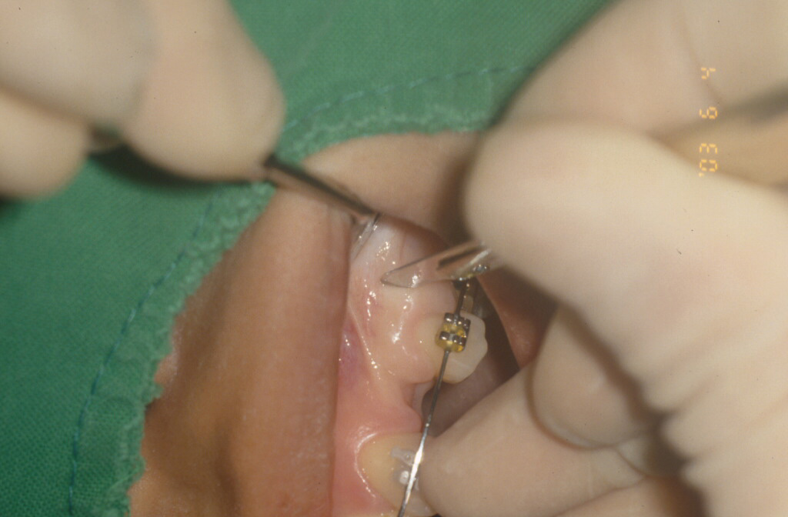
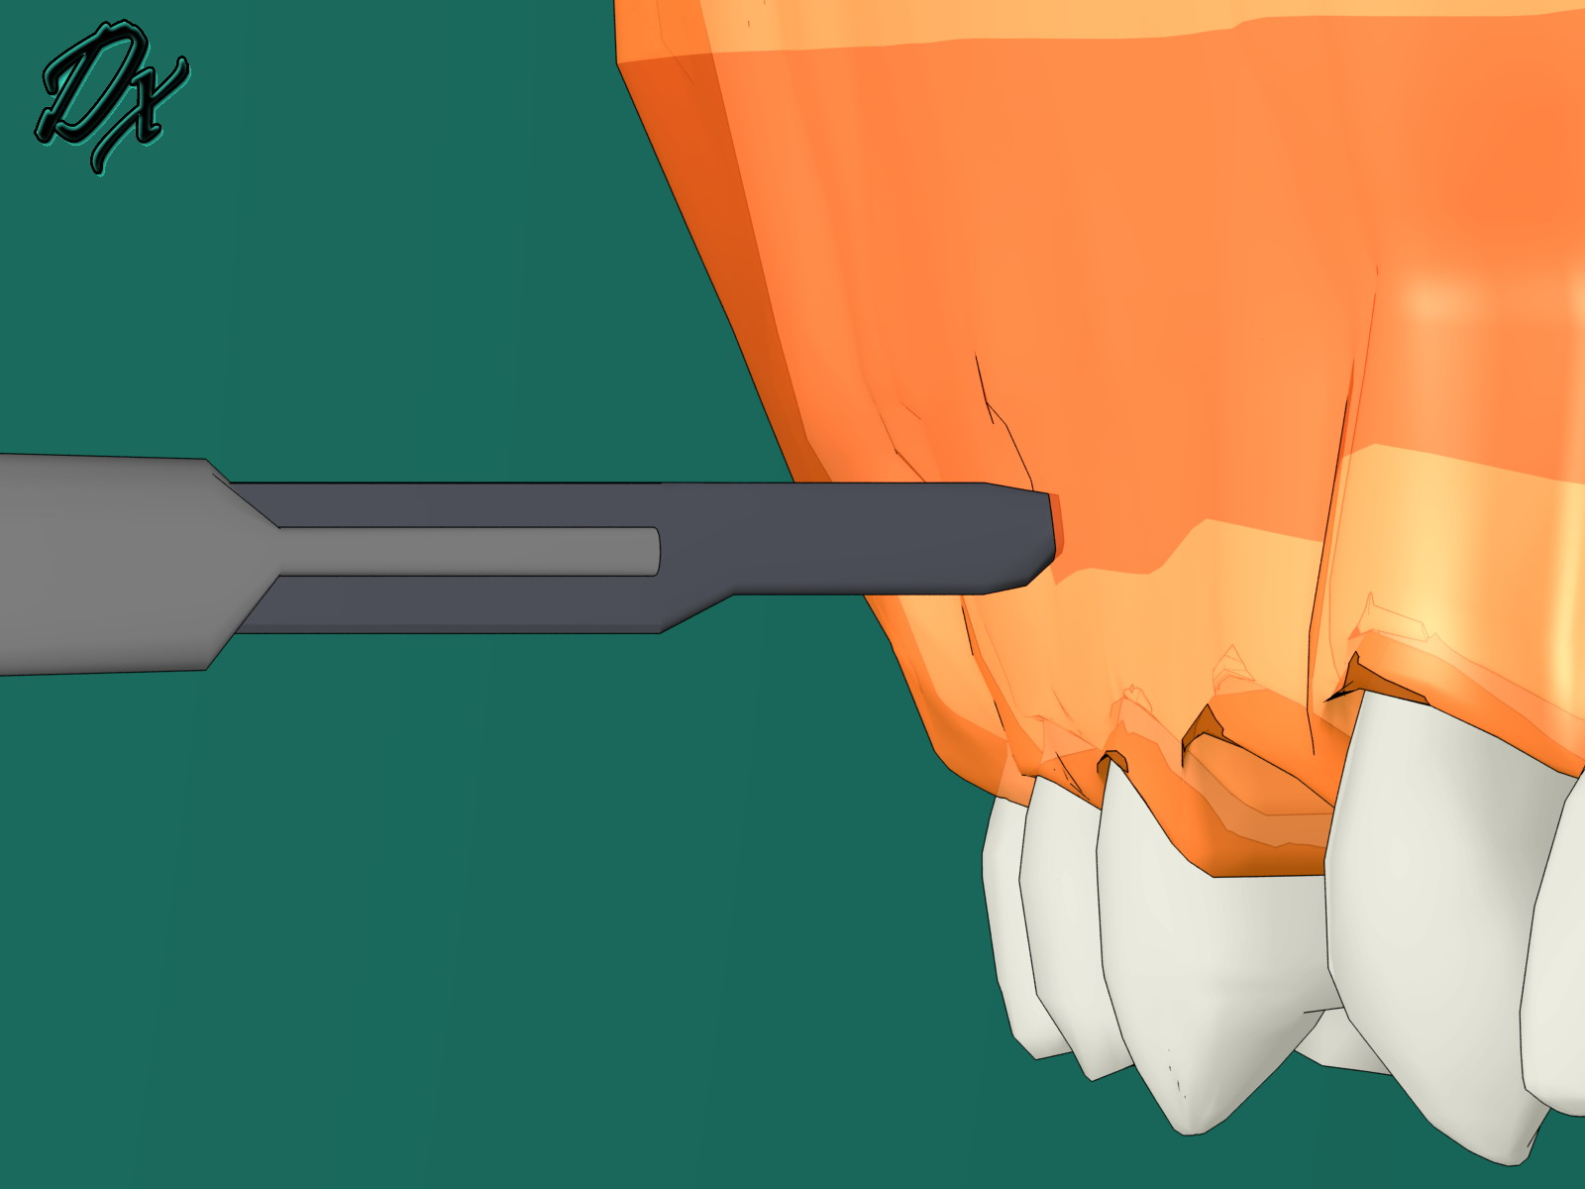
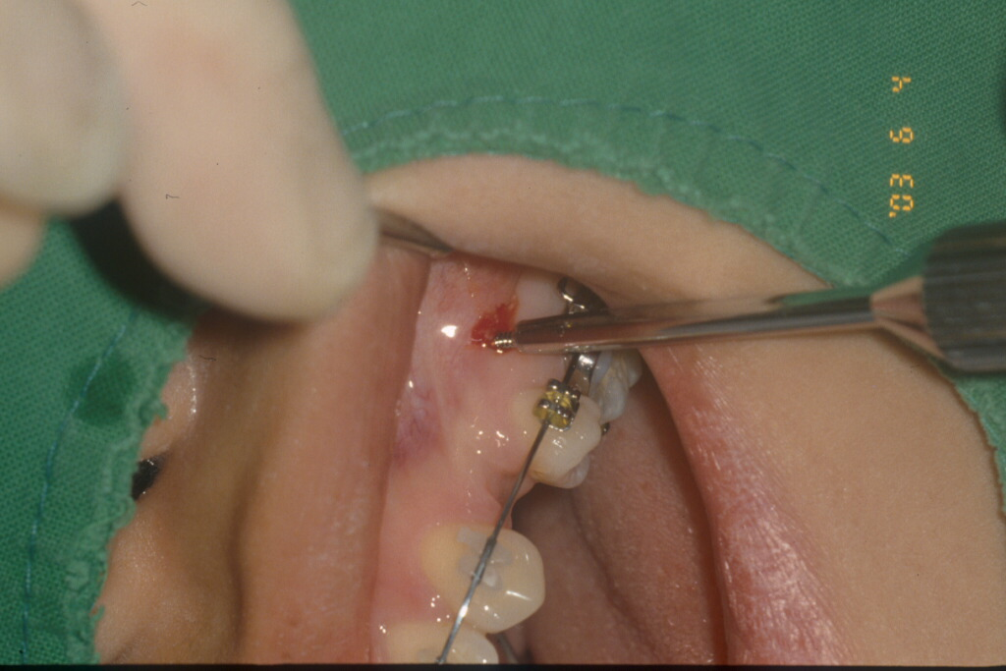

Fig.11. Make vertical incision within 4mm on movable soft tissue (not attached gingiva) to prevent rolling of soft tissue when drilling or inserting microimplants.
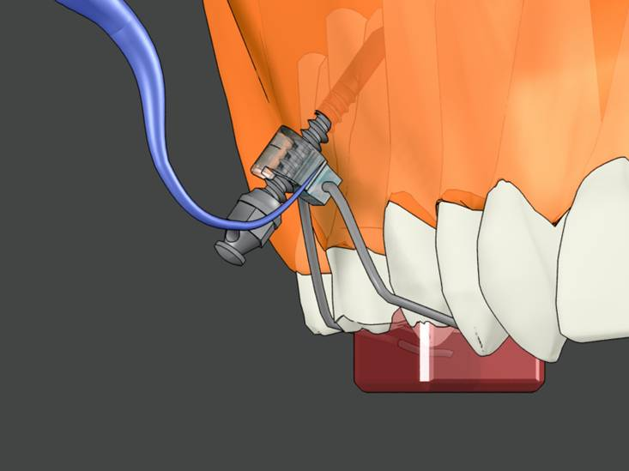
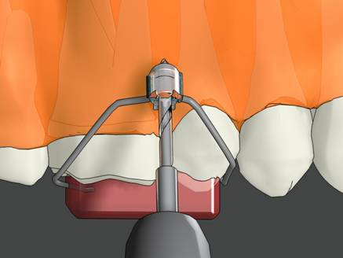
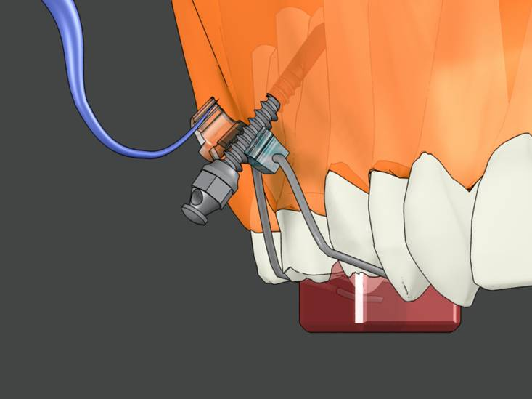

Fig.12. Drill guide (Dentos Inc. Daegu, Korea) makes possible to drill on movable soft tissue without vertical incision on movable soft tissue.

3) Microimplant driving
Microimplant driving methods can be divided into pre-drilling (self-tapping) method and drill-free (self-drilling) method. When we drill in advance, we can insert microimplant to the direction of drill.
However most people feel drilling is annoying, so favor drill-free method. Most microimplants in the market are made of strong titanium alloys, not of a little pure titanium, so even diameter of 1.2mm-1.3mm may be inserted without drilling. However since hardness of alveolar bone varies with the persons and the sites, if we feel a little heavy resistance when driving microimplants by drill-free method, we should remove the microimplants and change to pre-drilling method.
We may use engine driven method to insert microimplant, using speed reduction contra angle(256:1; about 30 rpm) like prosthetic implants, but this may lead to more possibility of microimplant breakage, thus it is safer to use hand driver to feel resistance of microimplant driving torque. We should never give excessive force, because if microimplant is broken during driving, it may be a little troublesome to remove.
Long hand driver may be used on buccal areas of mandible and maxilla. On the sites where long hand driver cannot be ewached (ex, palatal or retromolar area, etc), short hand driver may be used (Fig.13). However, short hand driver is inconvenient to handle. So, recently developed Hand-driven Contrangle (Fig.14) may be a better choice. Hand -driven contrangle driver can be connected to low speed contraangle (1:1) in dental unit chair. Engine driver of appropriate size should be attached to the contraangle, and then microimplant should be fixed to engine driver (Fig.15).

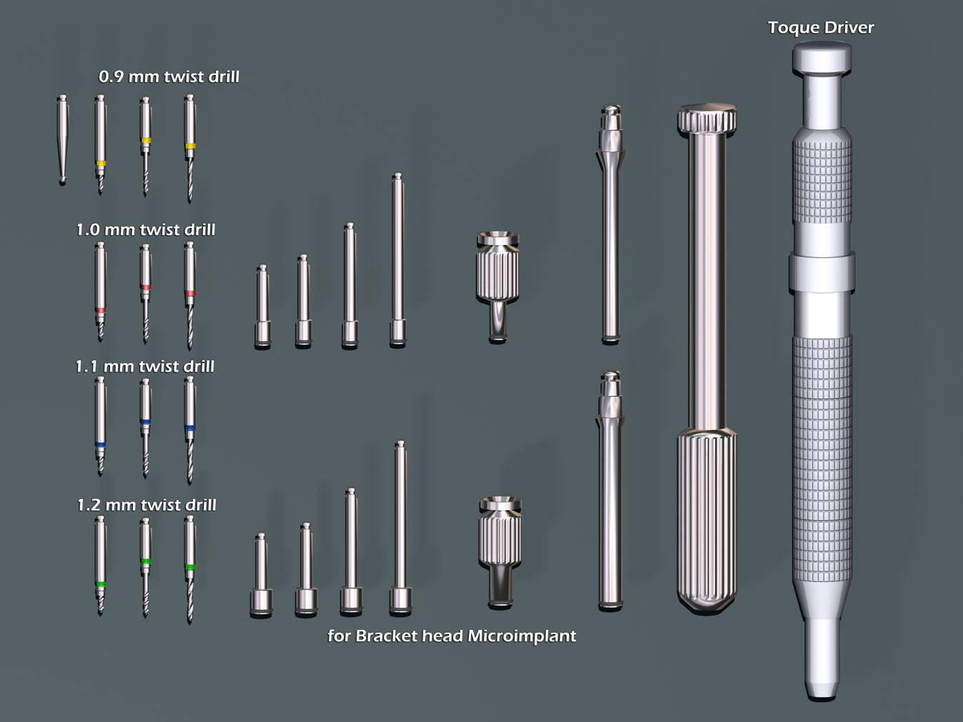

Fig.13. Several sizes of pilot drills and different kinds of drivers ( Dentos Inc., Daegu, Korea).

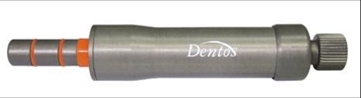
Fig.14. Hand-driven contraangle ( Dentos Inc. Daegu, Korea).

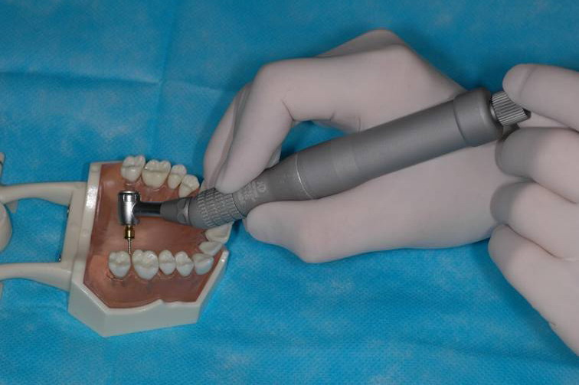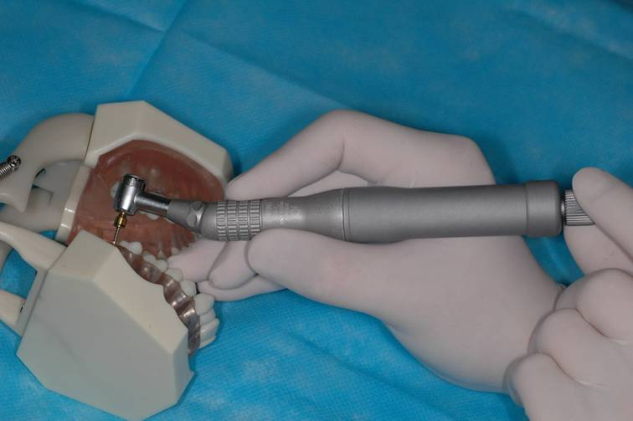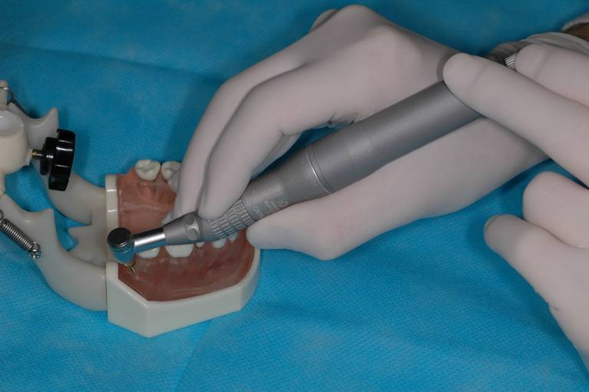
Fig.15. On the sites where long hand driver is not accessible, like maxillary tuberosity area and palatal area, mandibular retromolar areas etc, it is better to use Hand-driven contrangle driver.

4) Special attention after inserting microimplants.
Although good early fixation is achieved, inflammation should lead microimplant to be movable and loosened. Therefore to prevent inflammation, implanted site should be always keep clean by water irrigation or soft toothbrush. Also patients should be warned not to touch microimplant by their fingers.
Antibiotics prescription is not necessary with microimplant installation without incision. Also analgesics or NSAIDs is not necessary, for microimplant of small diameter rarely induces pain or swelling. However patients should be told to revisit the clinic when feeling pain during mastication. This kind of pain is usually derived form contact with root, so if diagnosed to root contact, you should move teeth away from microimplant. If you feel slight mobility, you may rather retighten microimplant, not remove it.

5) Explanation for possibility of failure
Microimplant has a failure rate of 5~25% depending on the dentists’ technique, patients’ type, insertion sites, and usually more failure occurs on mandible rather than maxilla. The patients should be fully noticed with the possibility of failure before starting microimplants.

